Assignment 4

## Data Flow Diagram for your choosen problem statement :

# LEVEL 0

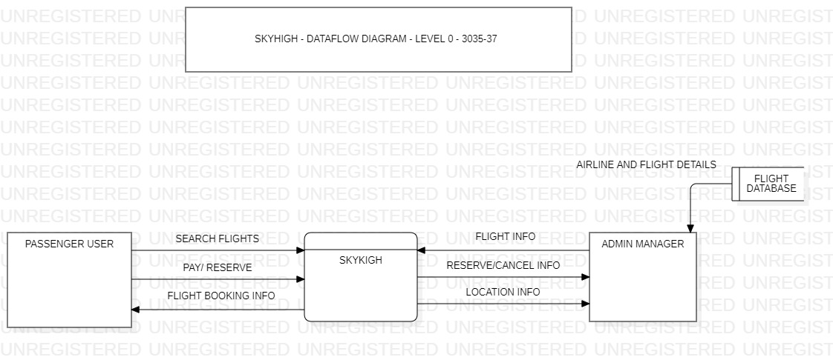

NOUN PHRASES:

* Search flight details ,
* pay or reserve,
* flight booking info,
* flight info,
* airline flight details ,
* location info

# LEVEL 1

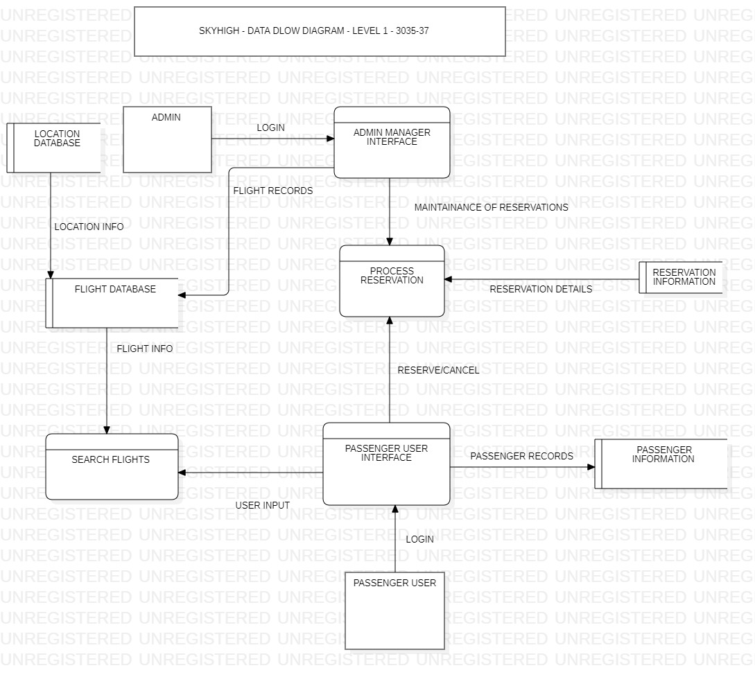

NOUN PHRASES:

* login,
* location info,
* maintainance of reservations ,
* reserve or cancel,
* passenger records,
* user inpput,
* flight info

VERB PHRASES: search flight details , process reservation

# LEVEL 2

* NOUN PHRASES: login, location info, maintainance of reservations , reserve or cancel, passenger records, user inpput, flight info,airline records, flight records, display details, query inputs, management of details, validation of payment, alteration of reservatiopn, reservation prompts
* VERB PHRASES: search flight details , process reservation, check flight availabilit, create reservation, modify reservation, cancel reservation, validate payment, confirm reservation, show flight details, search flights by destination, search flights by departure date

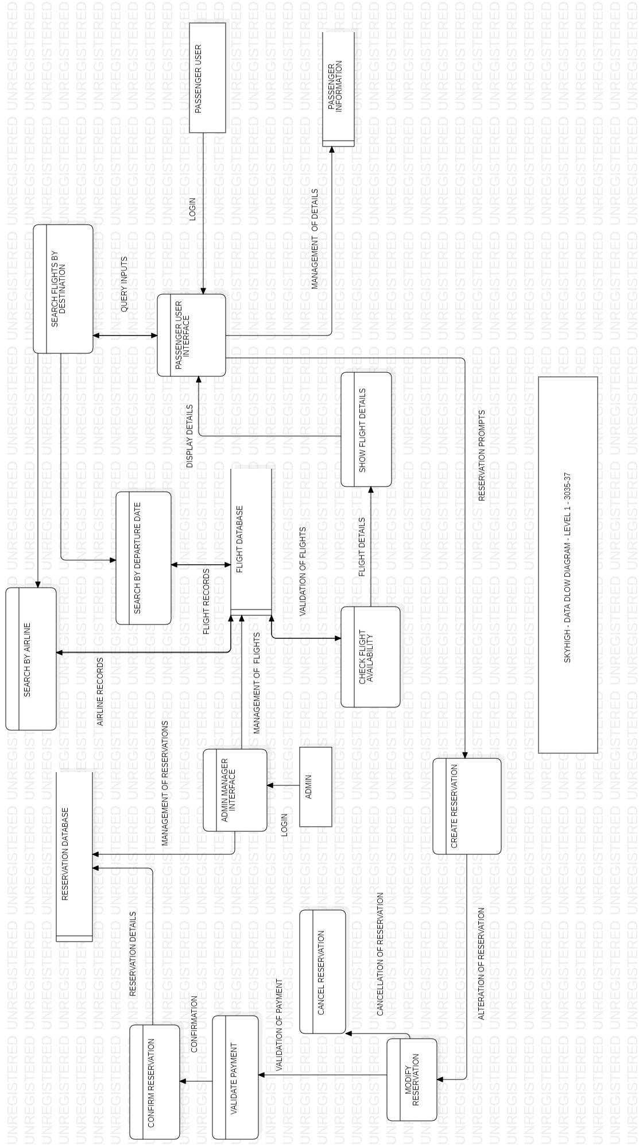

# LEVEL 3

* NOUN PHRASES: login, location info, maintainance of reservations , reserve or cancel, passenger records, user inpput, flight info,airline records, flight records, display details, query inputs, management of details, validation of payment, alteration of reservatiopn, reservation prompts,
* VERB PHRASES: search flight details , process reservation, check flight availabilit, create reservation, modify reservation, cancel reservation, validate payment, confirm reservation, show flight details, search flights by destination, search flights by departure date

